PYTHON ACTIVITY BASED LEARNING
PROBLEM 1
Problem Statement:
University Scholarship Allocation: Design a system that evaluates applicants using aggregate marks, subject-wise minimum scores, attendance, and income criteria, ranks eligible students, and resolves ties using predefined rules
1. Objective
To develop a program that evaluates scholarship applicants based on aggregate marks, subject-wise minimum marks, attendance percentage, and family income. The system identifies eligible students, ranks them according to merit, and resolves ties using predefined rules.
2. Program (Python)
# University Scholarship Allocationstudents = [ ["Ravi", 90, 75, 85, 40000], ["Sita", 90, 80, 90, 35000], ["Ram", 65, 70, 80, 30000], ["Priya", 85, 60, 75, 45000]]eligible = []for s in students: name, marks, subject, attendance, income = s if (marks >= 70 and subject >= 50 and attendance >= 75 and income <= 50000): eligible.append(s)# Ranking: aggregate marks, subject marks,# attendance (higher values first), income (lower first)eligible.sort(key=lambda s: (-s[1], -s[2], -s[3], s[4]))print("Eligible Scholarship Applicants:")print("Name Marks Subject Attendance Income")for s in eligible: print(s[0], s[1], s[2], s[3], s[4])print("\nScholarship Ranking:")for rank, s in enumerate(eligible, start=1): print(rank, "-", s[0])
3. Algorithm
- Start.
- Read the applicant details: name, aggregate marks, subject marks, attendance, and family income.
- Check whether aggregate marks are at least 70.
- Check whether subject marks are at least 50.
- Check whether attendance is at least 75%.
- Check whether family income is ₹50,000 or less.
- If all conditions are satisfied, add the applicant to the eligible list.
- Sort eligible applicants by:
  - Higher aggregate marks.
  - Higher subject marks.
  - Higher attendance.
  - Lower family income.
- Assign ranks to the eligible applicants.
- Display the eligible list and scholarship ranking.
- Stop.
Flowchart
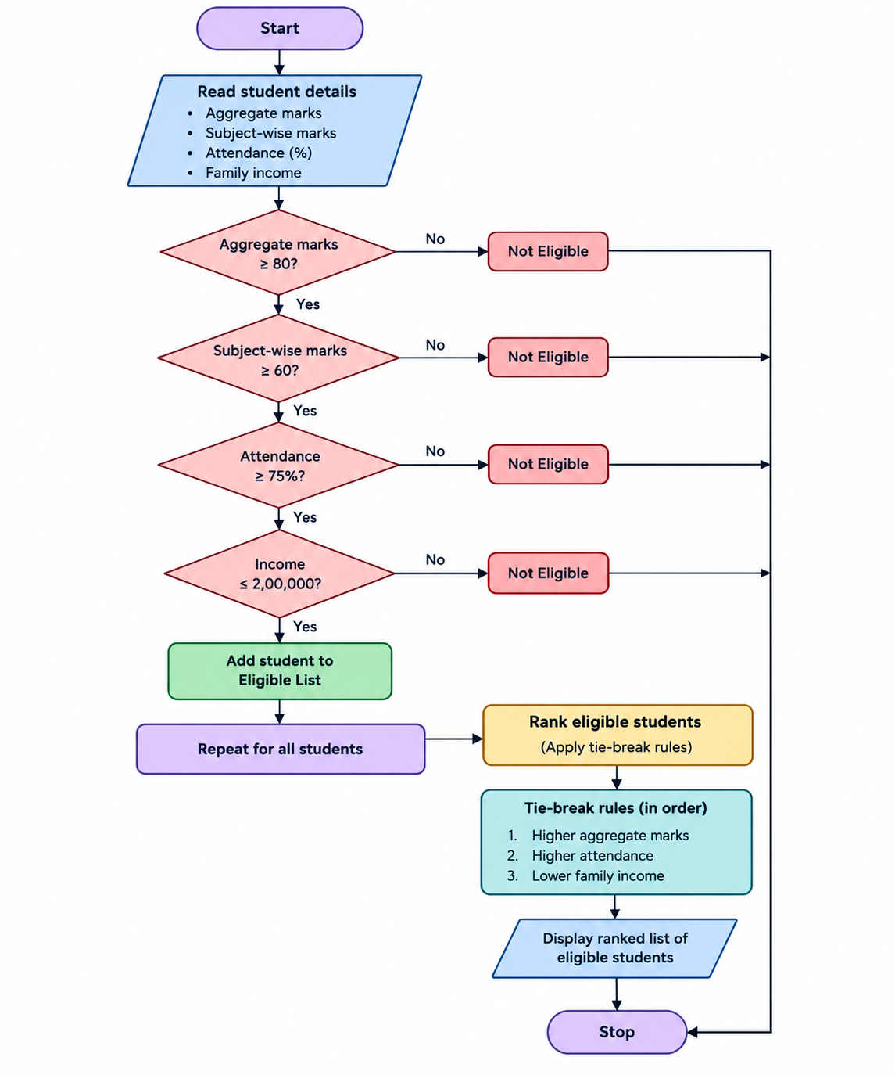
4. Pseudocode
BEGIN
INPUT student details
eligible_list = empty list

FOR each student
IF aggregate_marks >= 70 AND
subject_marks >= 50 AND
attendance >= 75 AND
family_income <= 50000 THEN

ADD student to eligible_list
END IF
END FOR

SORT eligible_list BY
aggregate_marks DESCENDING,
subject_marks DESCENDING,
attendance DESCENDING,
family_income ASCENDING

rank = 1

FOR each student in eligible_list
DISPLAY rank, student details
rank = rank + 1
END FOR
END
5. Output
Eligible Scholarship Applicants:
Name Marks Subject Attendance Income
Sita 90 80 90 35000
Ravi 90 75 85 40000
Priya 85 60 75 45000

Scholarship Ranking:
1 - Sita
2 - Ravi
3 - Priya
Result: The program successfully identifies eligible students, excludes applicants who do not meet all criteria, and ranks the eligible applicants according to the predefined merit and tie-breaking rules.

